# Updating the Developer Documentation

## Introduction

The Educational Secure Data Service (ESDS) Developer Documentation consists of information and procedures application developers use to create applications on top of the ESDS technology.

The Developer documentation source XML files reside in a Github repository. When a change is made to the ESDS technology that is relevant to developers, it is necessary to update the documentation. The following guidelines and procedures are provided for the individual tasked with updating this documentation.

Two methods are provided. One method is for an individual with the ability to directly modify the XML code to make updates. The second method is for an individual using a text editor to make updates to the XML code.

### Method One: Updating the Developer Documentation XML Code directly in the Github Repository

**Note:** This method is for an individual with the ability to modify XML code directly. Method Two (below) is recommended for an individual to make changes to the XML code using a text editor.

Prerequisites

* Access to the Developer Documentation repository in Github. Experience with XML files and syntax.

Procedure

1. Access the Github repository and locate the developer documentation. (It is currently located at *inbloomdev/datastore_docs/doc-developer*.)
2. Find the location in the file where the change needs to be made.
3. Click on the **Edit** tab in the Github toolbar as shown below.
4. Modify the XML code as necessary.
5. After the XML file has been updated, commit the changes you made to the master.   
   **Note:** It is recommended, as part of the revision control best practices, that a detailed description of the change is included with the commit.
6. Describe the change you have made and click the **Commit Changes** button as shown below.

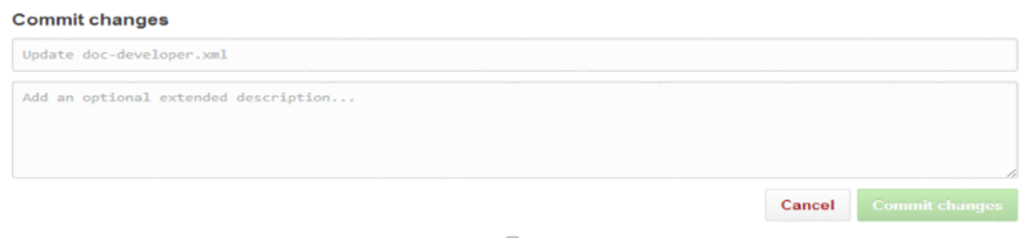

1. Review the XML file to ensure that the committed change was incorporated.

### Method Two: Using a Text Editor to Update Developer Documentation XML Code

Using a text editor that detects syntax errors to update the XML Developer documentation enables you to minimize the possibility of pushing invalid strings of XML to the Github repository. This method is highly recommended for an individual with minimal or no XML experience.

Prerequisites

* Access to the Developer Documentation repository in Github.
* Text editor such as OxygenXML.

Procedure

1. **Install a local version of the Github application for the operating system you are using. The download can be found at** [**https://windows.github.com/**](https://windows.github.com/)**.**
2. **Access the developer documentation repository in Github** and click  button in the bottom, right corner to check out the repository to your local directory. **This will create a Github directory on your computer’s hard drive with a clone of the Developer Documentation repository.**
3. Open the local Git and click  at the top, right corner of the window. This will ensure your local copy is synced with the version in GitHub.
4. Click  at the top, right corner of the local Git window and select **Open in Explorer** to open the local directory of documents. The directory will open at:  
   *YourName/MyDocuments/GitHub/datastore_docs*
5. Confirm that the directory folders have the current date.
6. From the local directory folder, open a file in the text editor and make necessary modifications.
7. Save the changes in the text editor.
8. Return to the local Git to view the changes you made and saved in the text editor.
9. Select a change and then in the top, left corner add a description for the change.  
   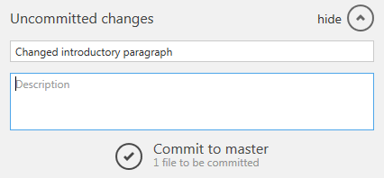
10. Once you have added the description of the change, click the under the **Description** field to commit the change to the master.
11. Once the change has been committed, sync the change back to the GitHub repository by clicking  at the top, right corner of the window.

Copyright Notice

© 2014 Educational Secure Data Service  
All rights reserved. No part of this document may be reproduced or transmitted in any form or by any means, electronic, mechanical, photocopying, recording, or otherwise, without prior written permission of ESDS.